**Benzie Bus Newsletter**

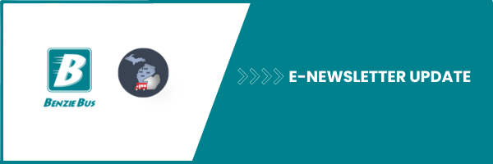

**Fast Facts:**

* Benzie Bus riders can now access a new online trip planning tool, the Michigan Department of Transportation (MDOT) is testing with four rural public transit agencies.
* Benzie Bus is one of the four participating public transit agencies along with Charlevoix County Transit, Roscommon County Transportation Authority, and WexExpress.
* The project is funded through a [United States Department of Transportation SMART grant](https://www.transportation.gov/grants).

**Exciting News for Benzie Bus Riders!**

We’re thrilled to announce that Benzie Bus is part of the Michigan Department of Transportation’s (MDOT) Office of Passenger Transportation [Advancing Rural Mobility](https://miruralmobility.org/) pilot project. This project has launched a new online trip-planning tool designed to improve riders' travel experiences. This launch is an important step toward ensuring that everyone in Benzie County has access to reliable and efficient transportation options, no matter where they live.

The trip planner is designed to enhance riders’ experience by providing personalized route options, seamless connections to other transit services, and real-time updates. Whether you're heading to work, a doctor’s appointment, or a community event, this tool will help you make the most of Benzie Bus services.

The screenshot below illustrates how Benzie County residents are using the trip planner to arrange transportation from Crystal Lake, MI, to Homestead, MI, for a doctors appointment in three weeks. They opted for the Benzie County Health Rides service because the trip meets the service’s medical eligibility requirements and is more than 14 days away, as indicated by the trip planner. Start planning your trips today and see how the trip-planner tool can make getting around easier!

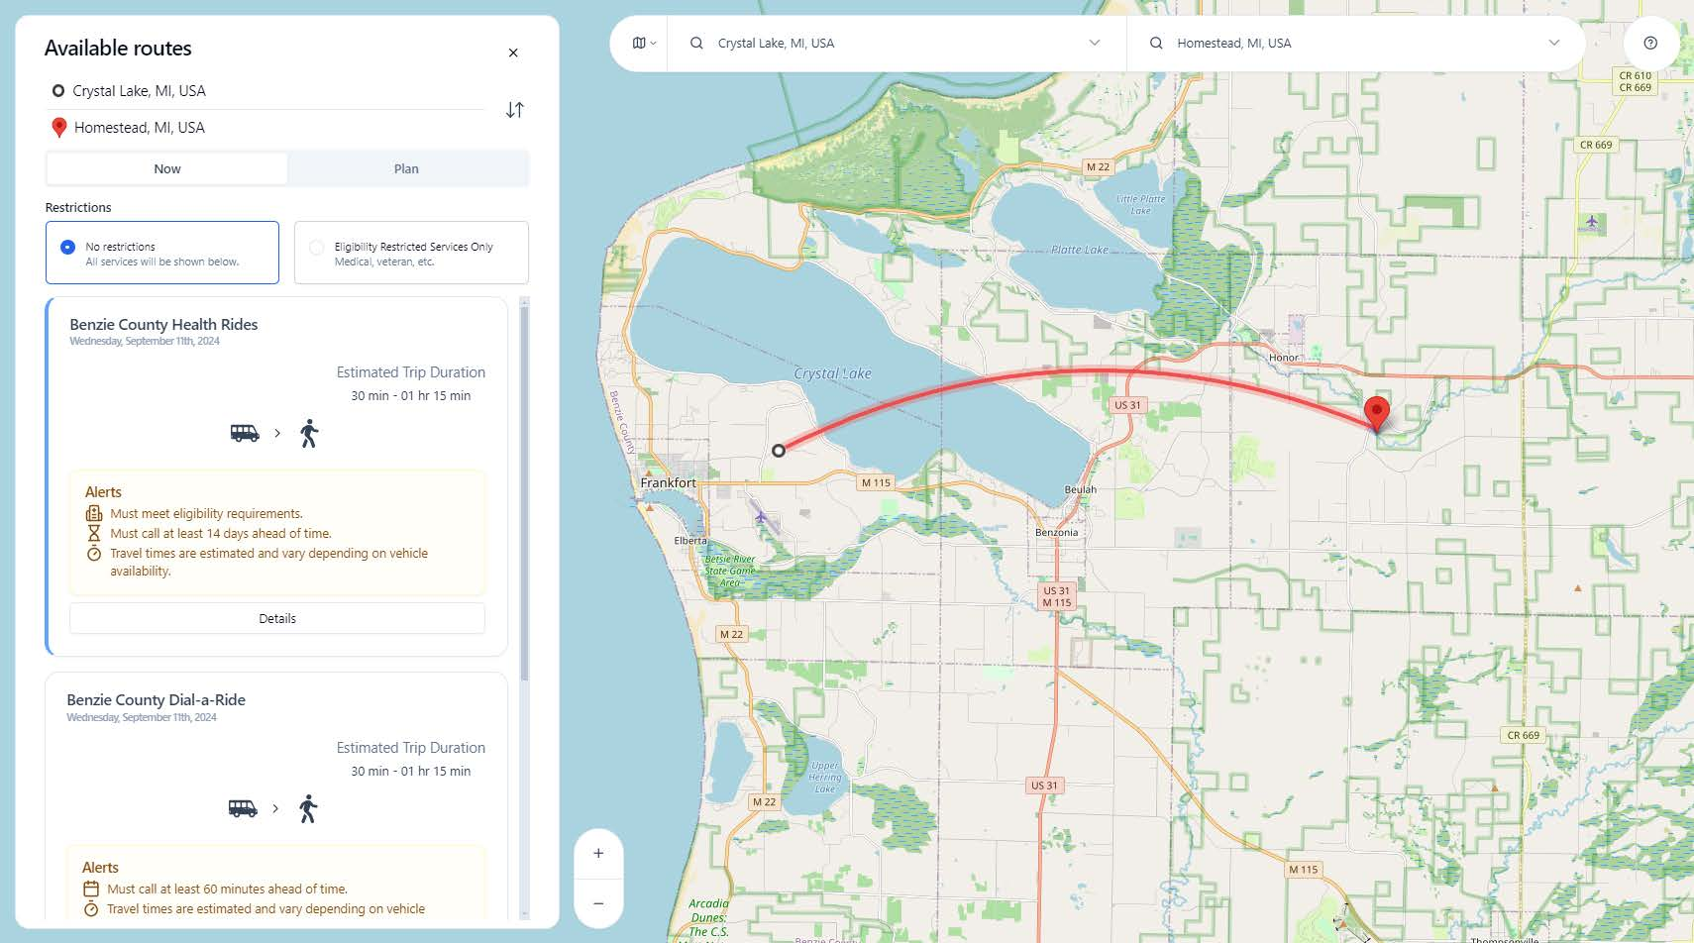

**](https://www.mitripplanner.org/help/)**